SRP Teaser Notes

- Companies that have been consistently at the top (the sustainable business leaders) are continually committed… is this going to match up with the reorganisation this year due to new ‘action led’ methodology?

- Extreme climate events – can we use other data to show increased number of extreme weather events?
- Label the dates of the various COPs and Paris Agreement and IPPC reports (other legislation?)
- Less than a decade – can we map the speed of the climate action so far against the time we have left?
- Pandemic date on timeline

Structure
- International top performers Top 10/20?
- International industry sectors focus
  - top 5 industries?
  - Top 5 performers
- Best practices uptake over the years

Net Zero
 | FTSE | DOW | CAC | IBEX
2020 | 45 | 9 | 17 | 21
2019
2018
2017

SBT
    - Companies who’ve set/committed to setting
 | FTSE | DOW | CAC | IBEX
2020 | 35/22 | 14/1 | 20/5 | 9/6
2019 | 81% FTSE Companies setting carbon reduction targets of any kind
2018 | 20/12  32% set or committed to SBTs
2017 | 8/10  Set or committed 18% |  | 38% Set or committed  2.5% SBT, 80% carbon target, 17.5% no target | 20% Set or committed  3% set SBT, 60% carbon target, 37% no target
2016 | 6/4 |  | 1/4
2015 | 1
    - 51% well below 2/1.5C

TCFD
    - Aligned/ mention
 | FTSE | DOW | CAC | IBEX | All
2020 | 56% | 37% |  |  | 50%
2019 | 37% | 23% |  |  | 37%
2018 | 15% / 26% mention | ~3% /~10% | ~13%, 25% mention | ~11 % / ~26% | 15%
2017

  - Scope 3
  - CDP
  - Communication of progress
- Geographical focus?
  - Top 10, top sector, top trend, comparison with other two
- Conclusion
- Methodology
  - How it has changed over the years
  - Kept it up to date to remain competitive and relevant to changing best practice

Leaderboards

2011

Z:\Marketing and Comms\1 - Content\5 - Sustainability reporting research\2013\FTSE 100 Carbon Reporting Final Version June 2011v2.xlsx

2012
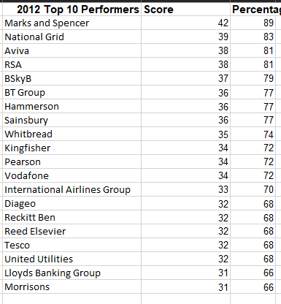

2013

FTSE
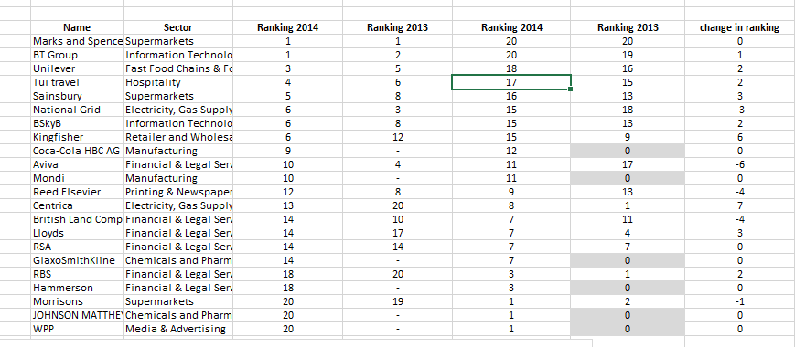

2014

FTSE
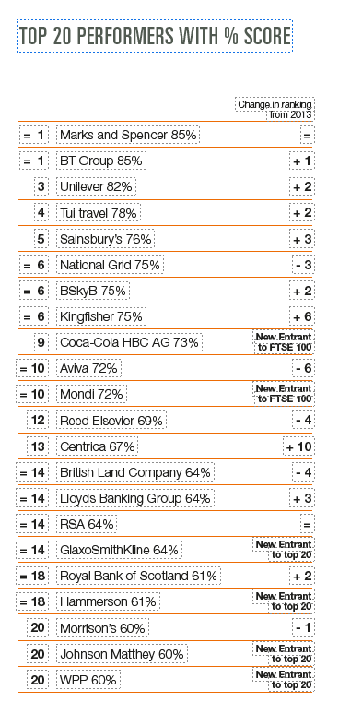

2016

FTSE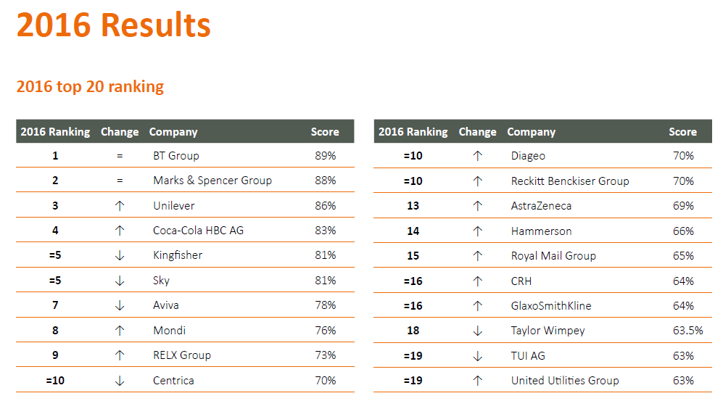

IBEX

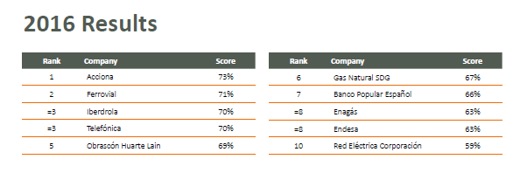

2017
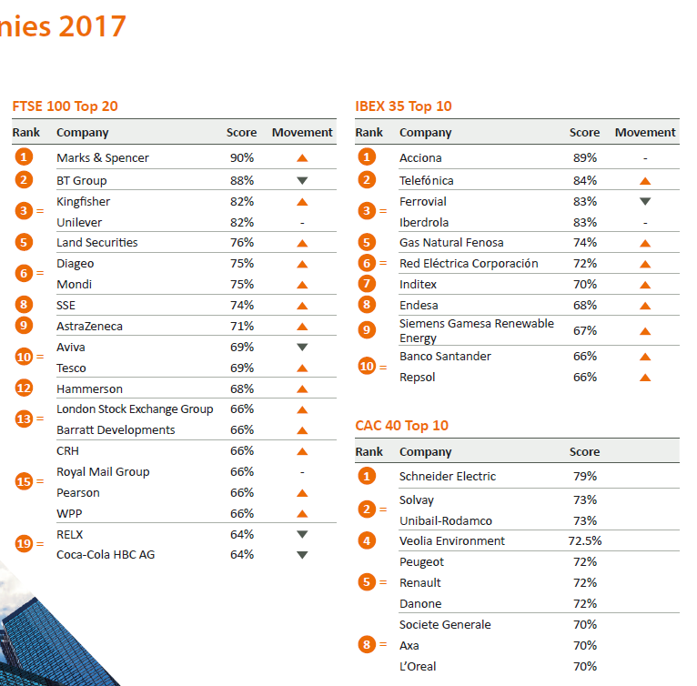2019

FTSE
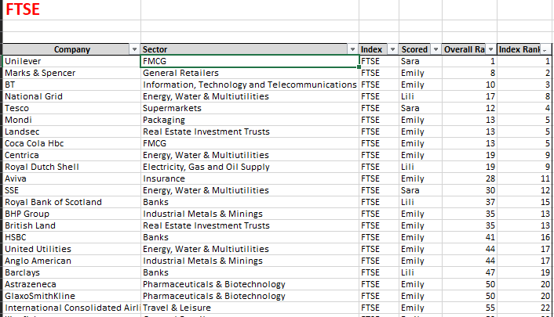

2018

International
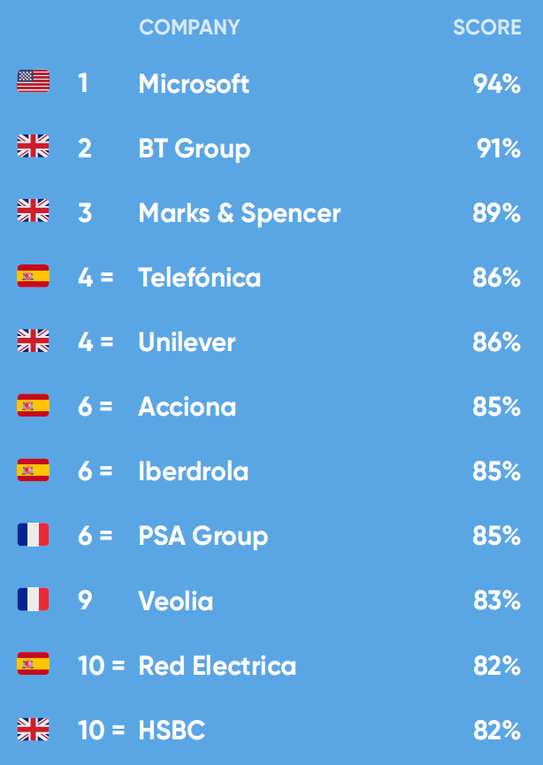

FTSE
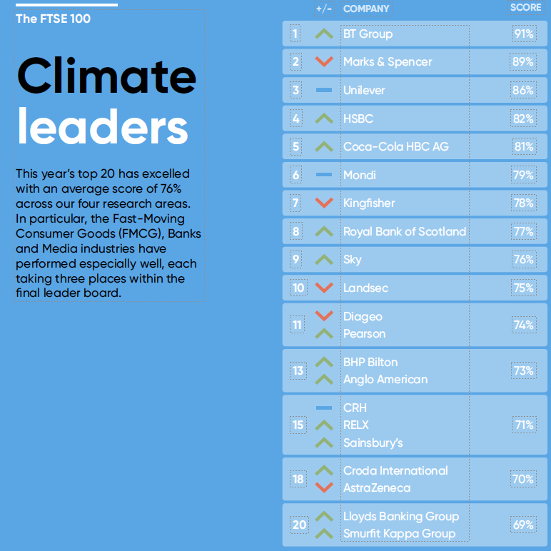

2019

International
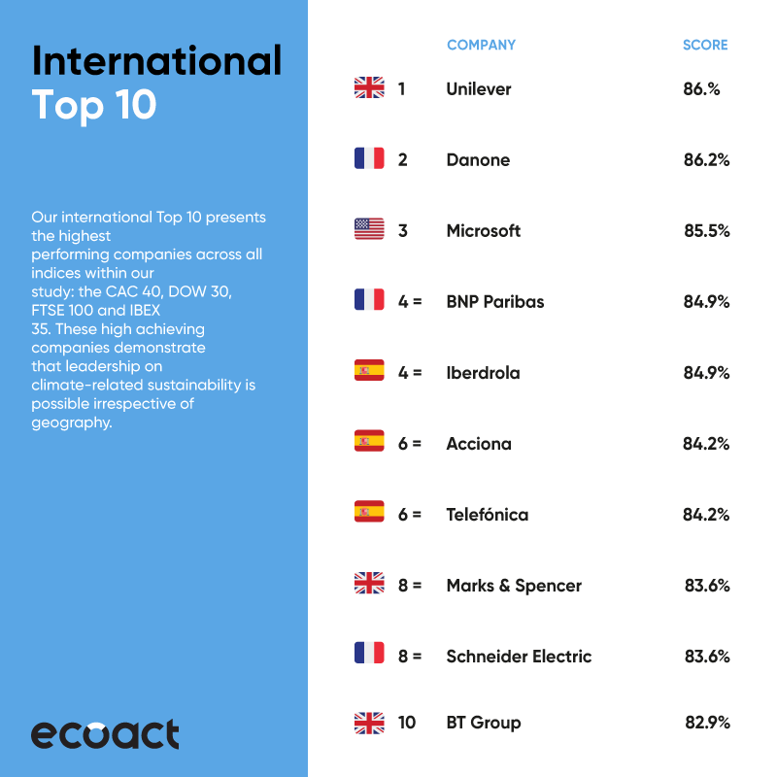

FTSE
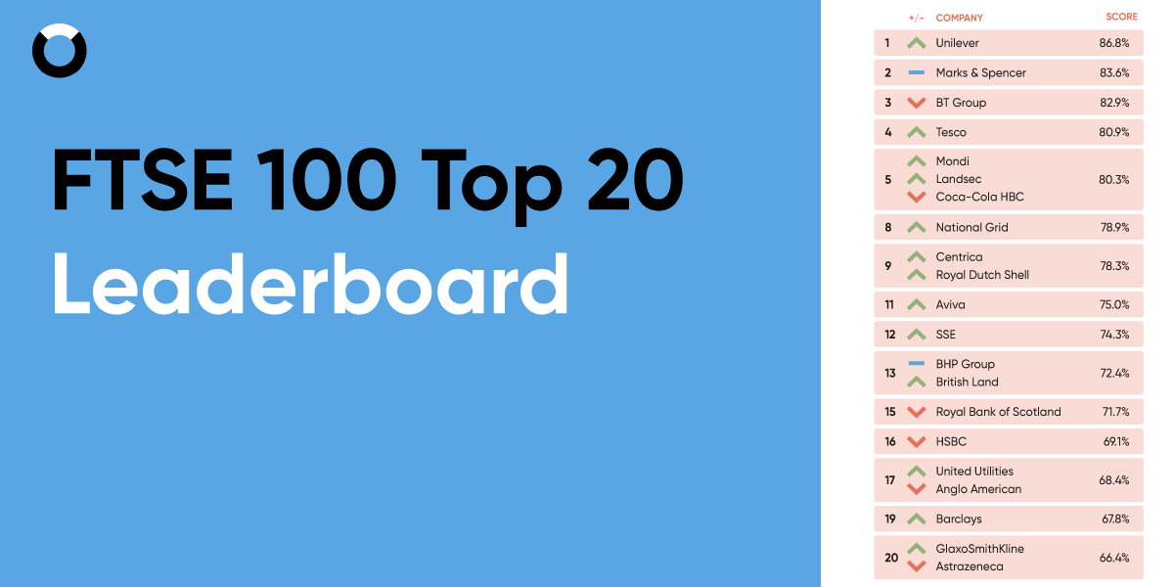

CAC
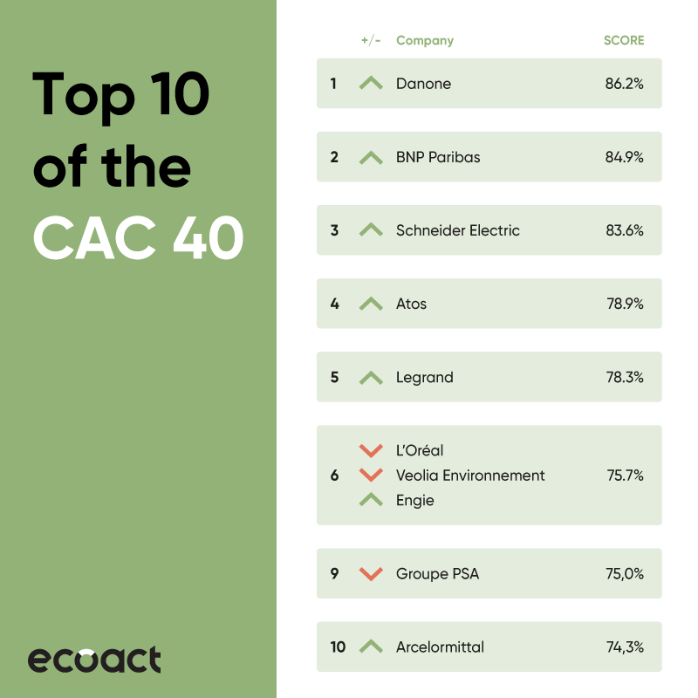

DOW
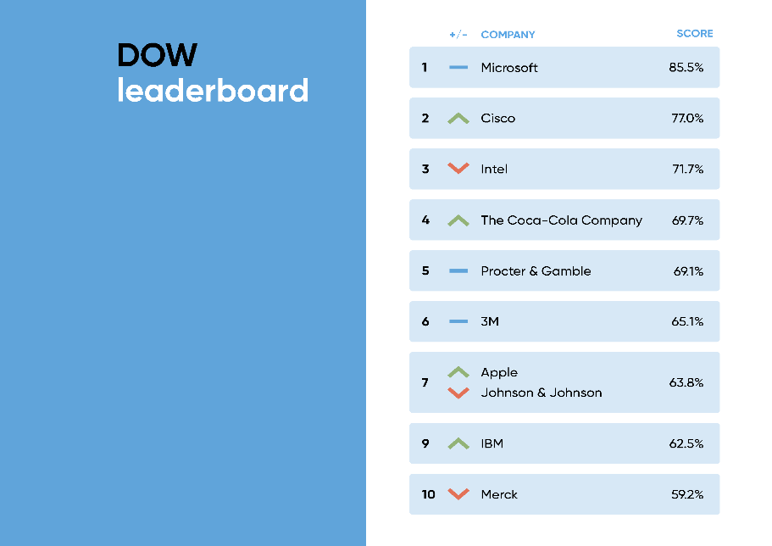

IBEX
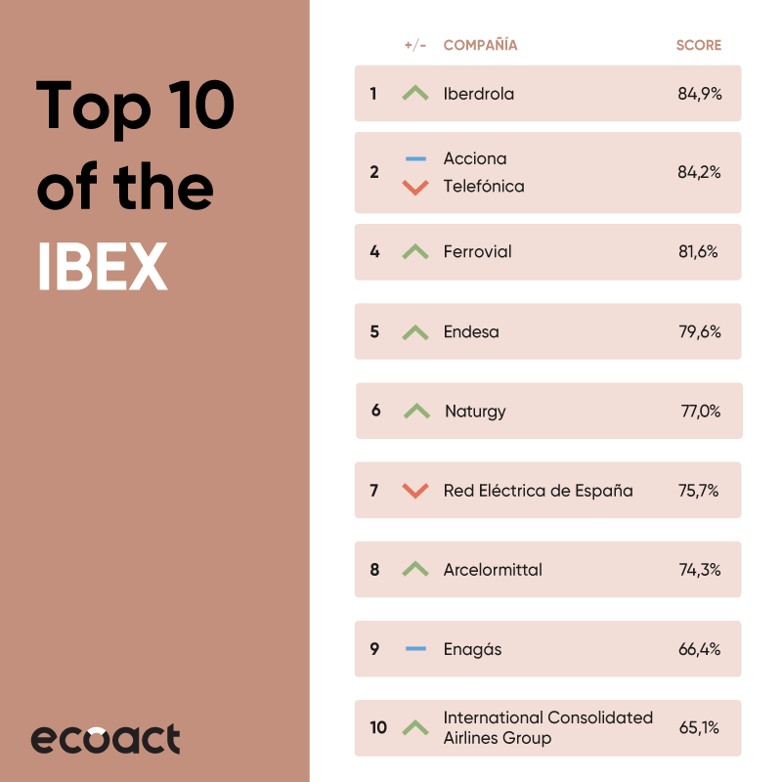

2020

International
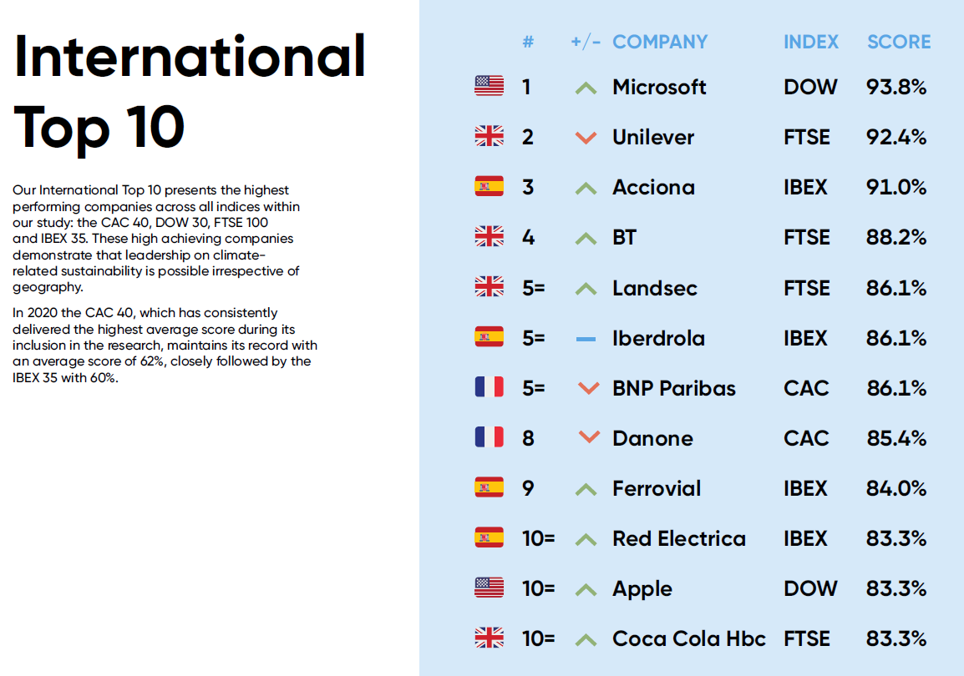

FTSE
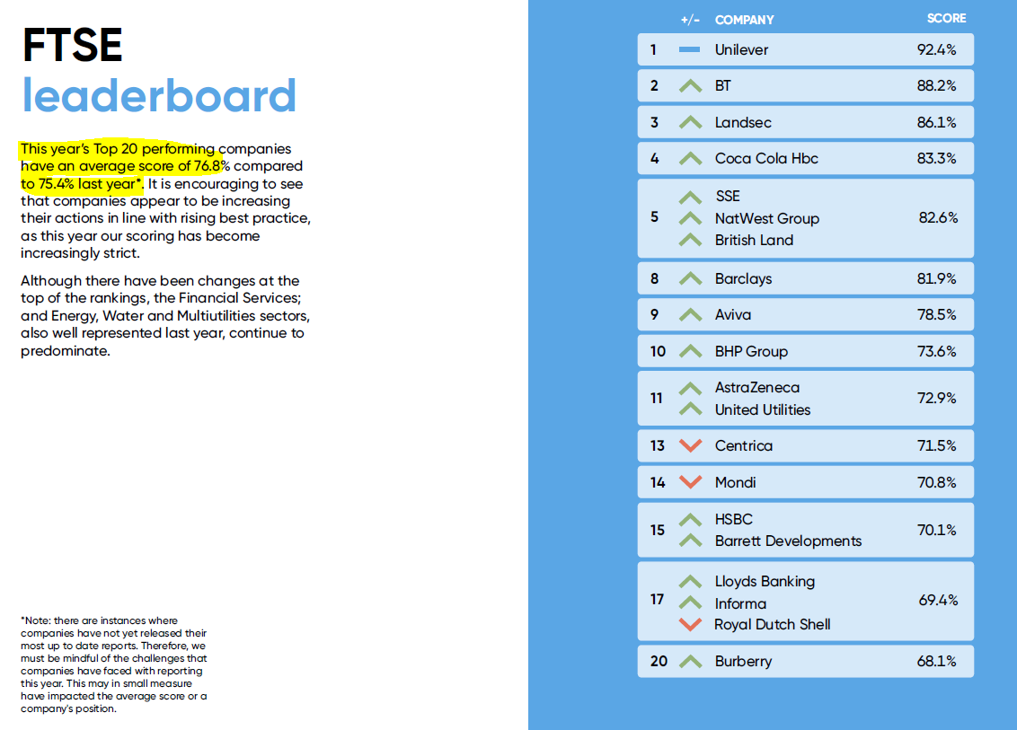

DOW
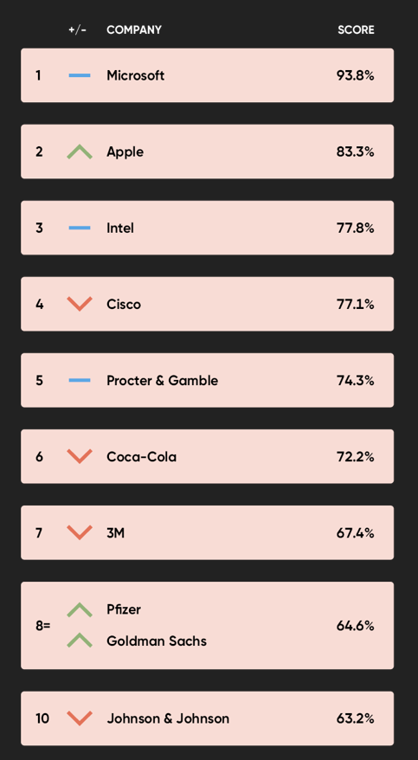

CAC
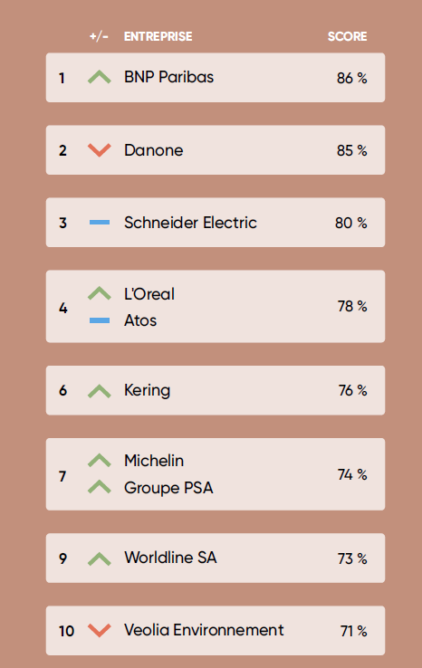

IBEX
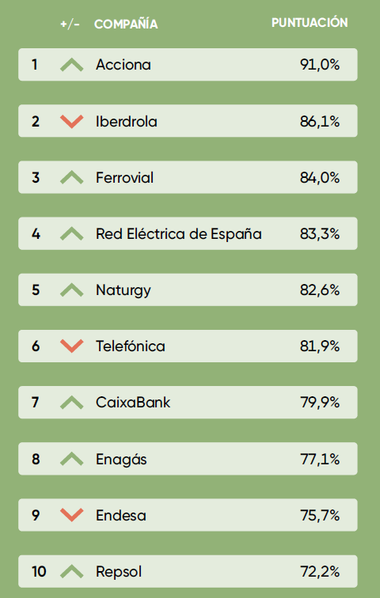

Average performance
- The Top 10 leaderboard as it stands each year, movers up and down etc.
- …followed by a FTSE Top 10 over the past 10 years

5 year comparison
Page 16 2015
Cumulative scores top 5 –
- M&S
- BT
- Sky
- Aviva
- Kingfisher
- 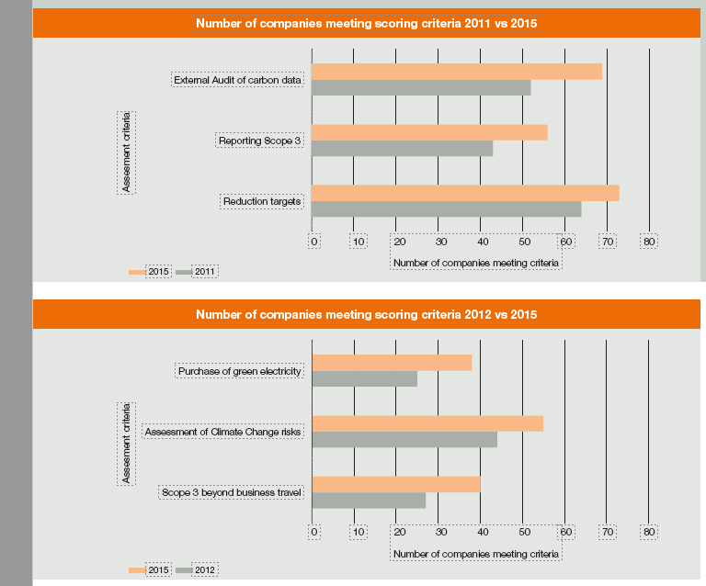
2012 - 47%

Net Zero

2019
20% of the global companies committed to Net Zero (or carbon neutrality
15% of FTSE 100
10% of the DOW
- Due to the lack of internationally conﬁrmed deﬁnition, the term is often used interchangeably with carbon neutrality. Therefore, provided commitment to an equally ambitious goal has been made, either terminology has been accepted.)

2020
45% of the global companies committed to Net Zero (or carbon neutrality ^) (data dashboard)
45% of FTSE100 – maybe this is the difference between the above and below?
59% Companies deﬁning Net Zero/ carbon neutrality commitments (page 35). Is this more because it is the number that are defining? “of those companies across all indices that have committed to Net Zero, only 59% provide a deﬁnition of the term), or is used interchangeably with “carbon neutrality”, as we have found is often the case.”
30% of the DOW
Commitment by index
- IBEX 21 (big uplift from 2019 – partly due to Gov’s commitments to Net Zero Dec 2019, partly …..The Spanish Green Growth Group is a collective of large Spanish corporates committed to low-carbon green growth and membership covers around 50% of the IBEX 35 partly
- FTSE 45 (30% increase on last year), largest percentage uplift = again gov commitment related (June 2019)
- CAC 17
- DOW 9
- Total = 92/ 205? = 45%

At time of writing 120 countries

SBTs

2015
1 company set an SBT (BT). SBTi founded at COP 21 in 2015.

2016
6 companies set SBTs
IBEX: 1 company has set a SBT and a further 4 companies have committed to setting one in the next 2 years

2017
FTSE: 8 set targets, 10 more committed to set an SBT in the future. 62% set carbon target
CAC: 2.5% SBT, 80% carbon target, 17.5% no target
IBEX: 3% set SBT, 60% carbon target, 37% no target

Set or committed to setting an SBT:
FTSE: 18%
CAC: 38%
IBEX: 20%

2018
FTSE: 32% set or committed to SBTs
FTSE: 20% have SBTs (which is more than double last year) and 8% of these are SBTi approved

2019
81% FTSE Companies setting carbon reduction targets of any kind
SBTi raised the level of ambition required for a target to be deemed science-based. Any target set from October 2019 onwards must be aligned to a 1.5 or well below 2oC warming trajectory
28% aligned with the new, more ambitious target of 1.5c

2020
Between 2015 and 2020, companies with SBT-validated targets have reduced their emissions by 25%, against a backdrop of a 3.4% increase in industrial and energy emissions
57% of FTSE committed to setting SBTs -----51% are aligned with the new, more ambitious target compared to 28% in 2019
46% of FTSE verified by SBTi
50% of the DOW committed to setting SBTs
67% FTSE Companies setting carbon reduction targets of any kind
SBTFI – finalised in autumn 2020?

Carbon reporting and reductions

2012
61 have achieved some sort of reduction in either absolute footprint or carbon intensity. 64 companies are setting reduction targets(pg 17 2015).

2013
FTSE: 97 companies report on carbon
FTSE: 66 have achieved some sort of reduction in either absolute footprint or carbon intensity
FTSE: 70 companies set carbon targets as part of their carbon strategy

2014
FTSE: 99 companies reported on carbon
FTSE: 76 companies set carbon targets as part of their carbon strategy

2015
99 companies reported on carbon. 69 companies now have their carbon data externally audited, a 33% increase since 2011. Reduction targets are now being set by 73 companies,

2016
FTSE: 99 companies reported on carbon. (Page 11 2016)
IBEX: 22 companies set a carbon reduction target 14 have demonstrated reduction in relative/absolute emissions compared to previous year
90% of companies with SBTs have shown either an absolute or relative reduction in year-on-year emissions between 2016 and 2017.

2017
FTSE: 99 companies reported on carbon. 70 FTSE set carbon reduction targets
90% of companies with SBTs have shown either an absolute or relative reduction in year-on-year emissions between 2016 and 2017.

2018
FTSE: 75% set carbon reduction targets
FTSE: 32% set or committed to SBTs

2019
81% FTSE Companies setting carbon reduction targets of any kind

2020
67% FTSE Companies setting carbon reduction targets of any kind
Setting a target causes ACTION - actual decline in emissions
91% of companies which set an SBT display absolute reductions in their Scope 1 and 2 carbon emissions compared to only 59% of companies that do not set a carbon reduction target

TCFD

2017
Launched

2018
12% aligned globally
FTSE : 15% companies already report in line with TCFD ~ 26% mention (41% mention or align to the recommendations of the TCFD)
DOW: ~3 /4 %? (page 46 DOW 2020) ~10% mention
CAC: ~13% Aligned, 25% mention
IBEX: ~10/11 % aligned, ~ 26% mention

2019
38% aligned globally
37% FTSE…… 23% DOW

2020
50% all companies
56% FTSE……. 37% DOW

Scope 3
FTSE 100

2011
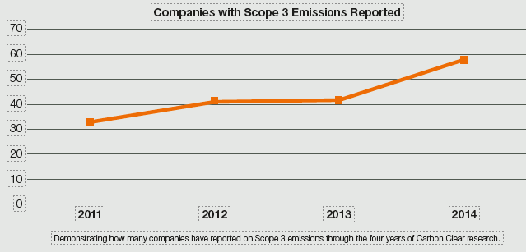

2012
42 companies reporting some scope 3 emissions (pg 7 2014 report)

2013
58 companies reporting some scope 3 emissions (pg 7 2014 report) [Different number on
42 companies reported their Scope 3 emissions data

2014
58 companies reported their Scope 3 emissions data

2015
56 reported some scope 3 (a 30% increase since 2011)

2016
66 reported some scope 3. (page 10 2016 – data on 2012, 2015, 2016)
FTSE: 24 companies assess supply chain risk

2017
FTSE: 66 report scope 3 data and 43 report scope 3 beyond business travel
FTSE: 10 companies providing evidence of value chain emission reductions
FTSE: 50 companies assess supply chain risk

2018
FTSE: 32 companies providing evidence of value chain emission reductions

2020
22% of the FTSE 100 have committed to setting and SBT and therefore, have to include Scope 3 in their targets to gain validation.
43% of all FTSE 100 companies have reported some reduction in their Scope 3 emissions in at least one Scope 3 category
only 20% show reductions across multiple categories

CDP
Companies submitting to CDP
 | FTSE
2020
2019
2018
2017 | 92
2016 | 90
2015
2014 | 88
2013 | 56

2013
In September 2013, legislation mandating UK registered and publicly listed companies to report carbon emissions data in their annual report came into effect.

2014
This year is the first time that the companies assessed have been required by law to report their operational carbon emissions in their annual reports.
Although not a legislative requirement, 88 FTSE 100 companies submit disclosures to CDP.
85 companies have reported carbon data in their annual reports in 2014 as opposed to 56 companies in 2013. We note that this uplift may be a result of the new legislation. Furthermore, because company data was collected in June and July, there may be a few instances of companies that have not yet had to comply because of their year-end date. (pg 10 impact of legislation)

Purchasing Green Energy / renewables

2010

3% of the country’s electricity was generated from wind and solar

2012
25 companies purchasing some green energy

2013
39 companies purchasing some green energy
44 companies producing their own green energy

2015
38 purchased green electricity (34% increase from 2012 page 17 2015 – not sure how this marries up with the 25 listed in 2012?)

2016
Page 9 2016 has data on 2012, 2015 and 2016.
IBEX: 15 companies purchase good quality renewable electricity

2017
Companies using renewable energy:
FTSE: 66% (“65% Renewable energy use”)

CAC: 65% (26) 38% of companies in the CAC 40 do purchase renewables, and half generate some onsite.
IBEX: 68% (24) More than half (54%) of the IBEX 35 buy renewable energy, an increase of 11% compared to 2016. 3 companies have committed to RE100 and are already 100% renewable

2018
FTSE: 75% Renewable energy use

2019
77% FTSE 100 companies are now using or generating some renewable electricity
Commitment to 100% renewable electricity 28%

2020
Britain passed a signiﬁcant milestone in June having surpassed two months without using coal as part of the electricity generation mix. Renewables accounted for nearly half of Britain’s electricity generation (47%) in the ﬁrst quarter of 2020
68% of the FTSE 100 companies are now using or generating some renewable electricity either through self-generation or purchasing (lower than 2019 because of methodology)
Commitment to 100% renewable electricity this year has increased slightly from 28% (in 2019) to 33%

Carbon Offsetting

2012
13 doing some form of offsetting

2013
19 doing some form of offsetting

2014
15 doing some form of offsetting

2016
14 companies (5 carbon neutral)

2020
Task Force for Scaling-up the voluntary Carbon market launched September 2020.

Energy efficiency

2013
CRC Energy Efficiency – new legislation?

2014
ESOS introduced (part of article 8)

2020
91% of the FTSE 100 implementing energy efficient technology.
EV’s in fleet? 33% companies in the FTSE 100 are incorporating EVs into their ﬂeets or using charging stations Reflecting Gov brought forward the ban on the sale of new petrol and diesel cars from 2050 to 2040

Risks and Opportunities

2012
35 companies have assessed the risks of future climate change to their business (20% less than 55 in 2015?)

2013
41 companies identified at least some form climate change adaption and/or opportunities

2014
61 companies have performed a materiality assessment of the risks and opportunities of climate change

2015
40 mention business resilience/adaptations to risk from climate change. 55 companies have assessed the risks of future climate change to their business, a 20% increase since 2012

2016
66 companies show an assessment of materiality of climate change issues or an assessment of the risks climate change poses their business. (Page 12 2016)
FTSE: 23% mentioned climate change in the risk section of their annual reports
IBEX: 37% mentioned climate change in the risk section of their annual reports 25 companies make reference to the risks of climate change, only 8 extensive assessment
FTSE: 24% assess supply chain risk and value chain adaptation

2017
FTSE: 39% mentioned climate change in the risk section of their annual reports
IBEX: 57% mentioned climate change in the risk section of their annual reports
CAC: 85% acknowledging climate change as a business risk (same as ^ ?)
FTSE: 50% assess supply chain risk and value chain adaptation
CAC: 60% of companies examining and reporting assessments of adaptations in the value chain
IBEX: 14% of companies assess supply chain risks

2019
FTSE and DOW - both climate-related risk mitigation plans and risk assessments rose considerably from 2018 to 2019
2019 – CSA 74% FTSE are assessing and disclosing climate risks

Overall, the number of companies using CSA has rapidly risen from 28% in 2019

2020
….To 42% in 2020
CSA -80% FTSE are assessing and disclosing climate risks

IPCC report

2014
The global 2°C target requires net zero emissions by 2075

Key dates – Net Zero targets and Legislation changes

2014
IPCC 5th assessment report: The global 2°C target requires net zero emissions by 2075 (final part in Jan)
The UN climate Summit held in New York in September 2014 was the first of a number of events leading up to…COP 21 in 2015
RE100 launched – 2020 had 240 global members 2021 – 300+
President Obama made action on climate change one of the major policy areas of his second term.
China has put in place a plan to cap emissions whilst India has set up a climate adaptation fund and made efforts to increase renewable energy.
In the UK, legislation came into force last year that has seen most publicly listed companies include their carbon footprint in their annual report

2015
Paris Conference of Parties (COP) to the UNFCCC negotiated the Paris Agreement – a landmark environmental accord that aimed to tackle climate change.
Net zero target included in the Paris Agreement, becoming an official global ambition
SBTi founded at COP 21.

2016
COP 26 : Launch of the "2050 Pathways Platform": 22 countries, 15 major cities and 196 companies, target carbon neutrality by 2050

2017
TCFD launched
One Planet Summit: Creation of the Coalition for Carbon Neutrality:
19 member states including UK & France

2018
IPCC Report on 1.5 degrees: States that limiting warming to 1.5°C is now imperative and requires net zero emissions by 2050

2019
Climate emergency is declared in several countries
Net zero legislation
Climate groups take to streets

June
UK and France set Net Zero target of 2050 – as well as Norway and Sweden and progress in more than 10 countries

Dec
Spanish government declared their intent to set a Net Zero target in December 2019

2020

Jan
Larry Fink, Chairman and CEO of BlackRock, the world’s largest asset manager with nearly $7 trillion
in investments, wrote his open letter to CEOs predicting a “fundamental reshaping of ﬁnance
Commitments to net zero grow rapidly
Over 1000/2000? companies are committed to science-based targets

November
USA – commits to net zero 2050 (Biden’s first week in office)
UK?? Thought this was in 2019? and USA set net zero targets for 2050. China for 2060
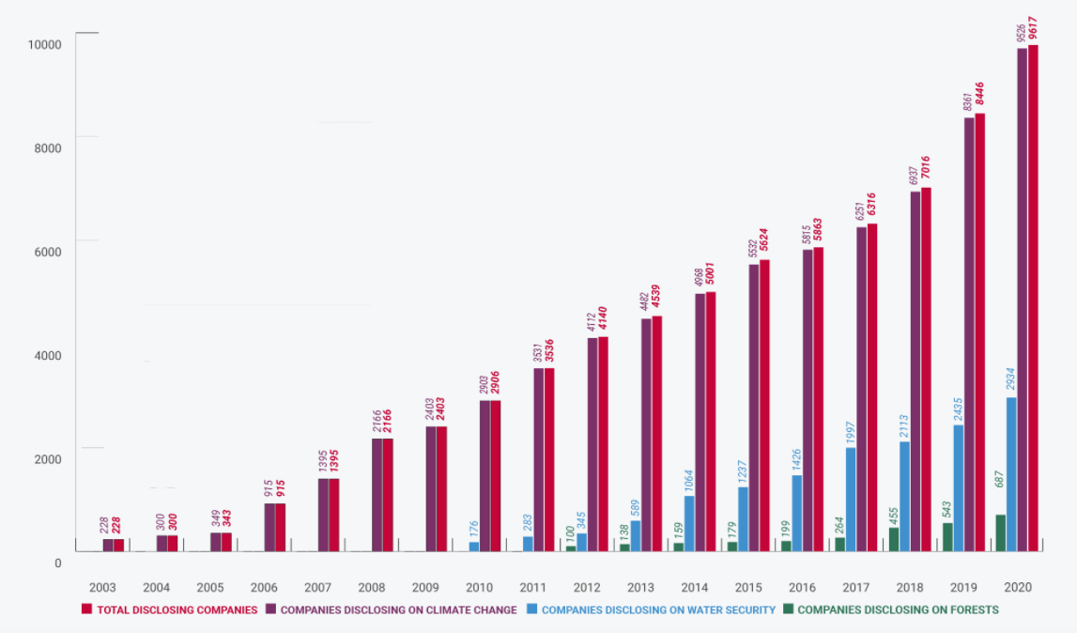
CDP

SBT Signatories
1602 to date

TCFD

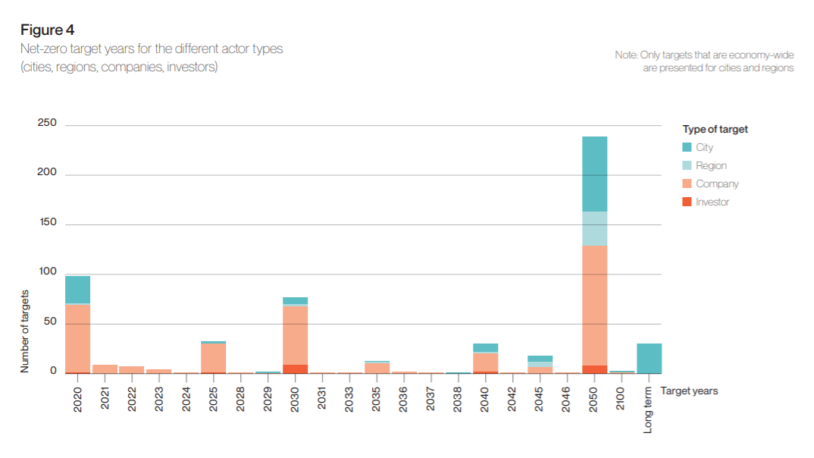
Race to Zero

